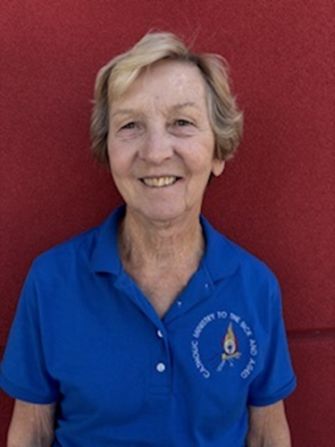
Connie Barre
Assistant Director, Ministry to the Sick and Aged
Diocese of Belleville

Connie Barre has been the Assistant Director of the Ministry to the Sick and Aged in the Diocese of Belleville for 35 years, working with Fr. Gene Neff, Director.
She was also a teacher for over 40 years while traveling with her husband Roger, who was in the Air Force. We have two daughters, Kelly (Steve) West and Jessica (Tom) Ysursa and six grandchildren.

